_________________ | ___________________  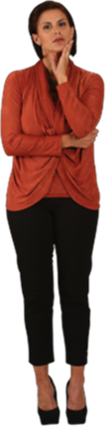 | _________________  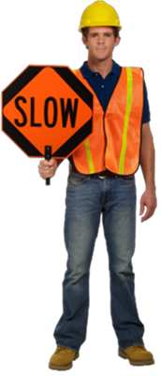
__________ ________________ |  | __________ _______________  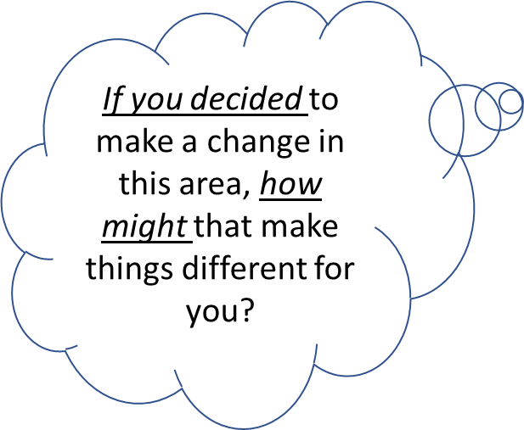
________ _____________ | ________ ______________ | ___ ___ ___  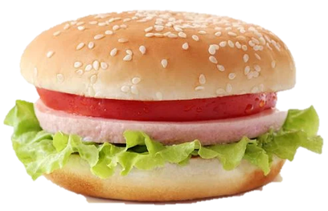
_NOTES:_____________________________________________________________________________________________________________________________________________________________________________________________________________________________________________________________________________________________________________________________________________

