_________________  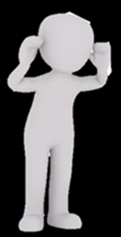 | ________ ___ ________ |  | __________ ________ _______  D: _______  A: _______  R: _______  N: _______
_______ ______ ___________________  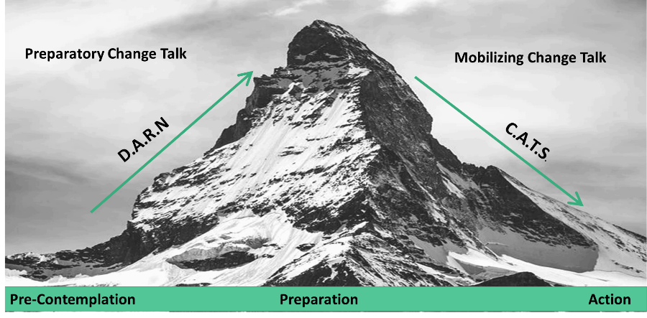 |  |  | ___________ ________ _____  C: _________  A: _________  T: _________
________________ | _______ ___________  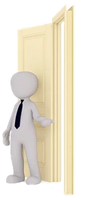 | ___________ ___________  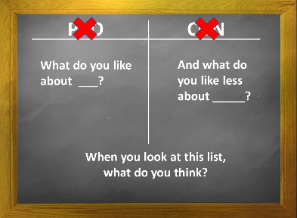
_NOTES:____________________________________________________________________________________________________________________________________________________________________________________________________________________________________________________________________________________________________________________________________________

